**e-shule**

*Software updates*

The following major changes have been done:

-Improved both the end user and backend User Interface

**Home page:**

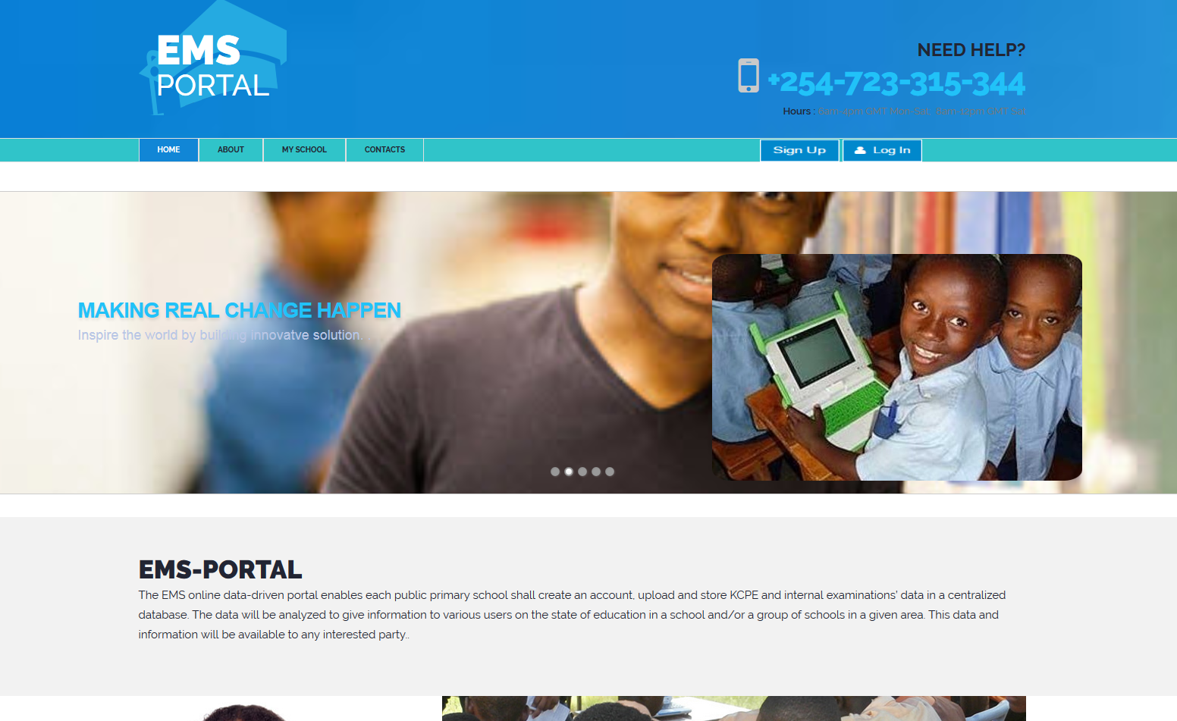

**About page:**

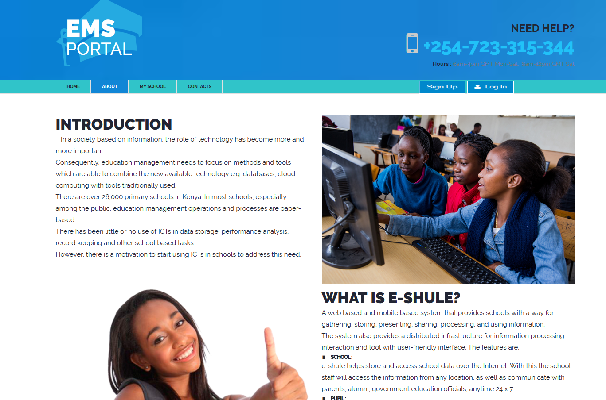

**My school page:**

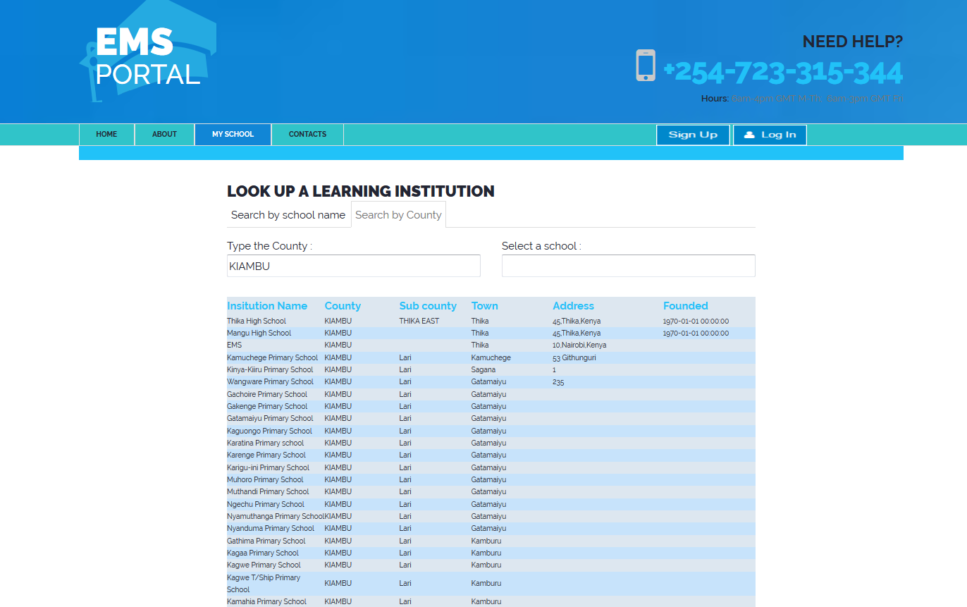

**Contact us page:**

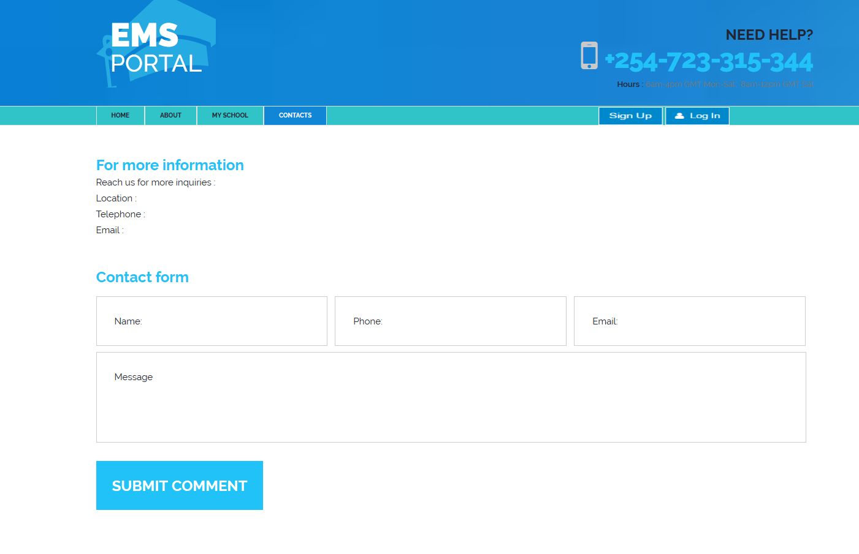

We have entered the marks that you sent us and the system can generate the marks accordingly, Generating report is done at the Ems Reports Module Exam Result Reports.

Attached also is a sample Pdf report.

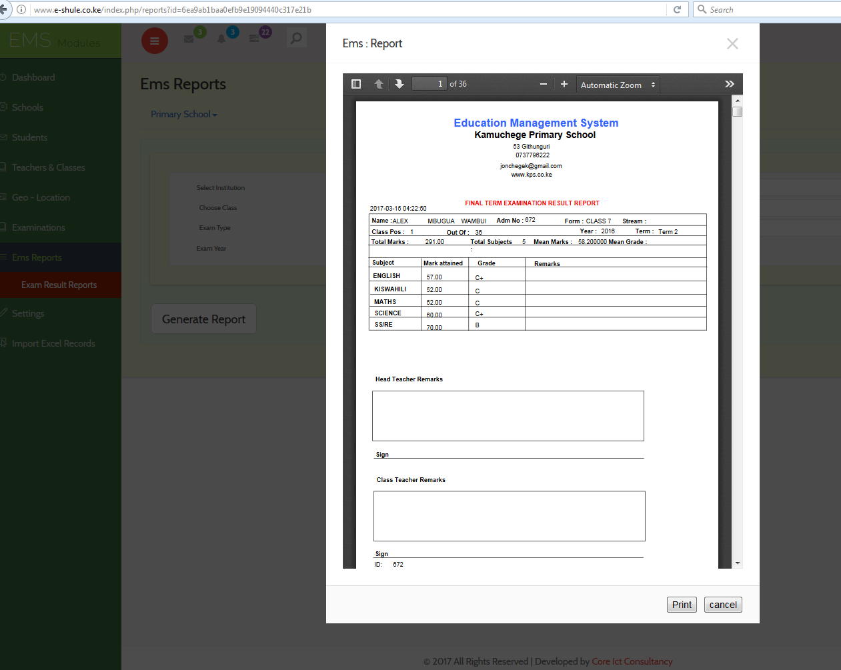

More varieties of reports can be selected using the Exam type drop down.

**NB:**

We formatted the excels sent enable the system import them.

To enter new data, let the system produce the student excel template with all the students name since this makes it easier.

We also added students that did not exist in the system.

Use the Empty excel to generate a system compatible exam fill sheet.

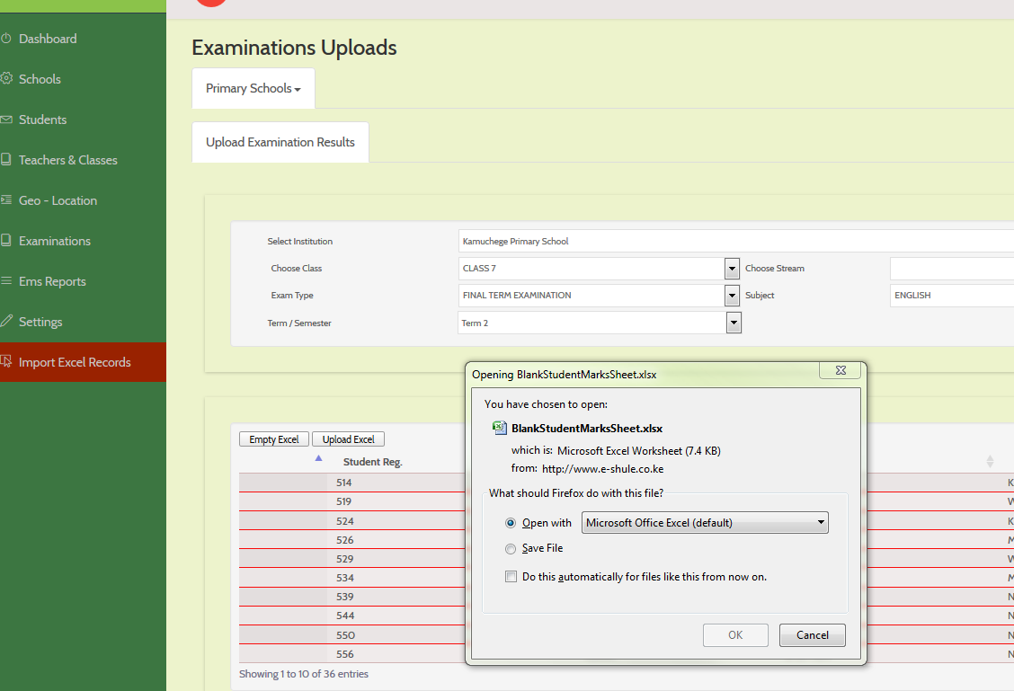

A sample excel generated by the system is as shown below:

Note the system generated student id:

